PHOTO OF NAAC PEAR TEAM
Cycle-1
26th & 27th February, 2006
Moirabari College
Moirabari : Morigaon : Assam

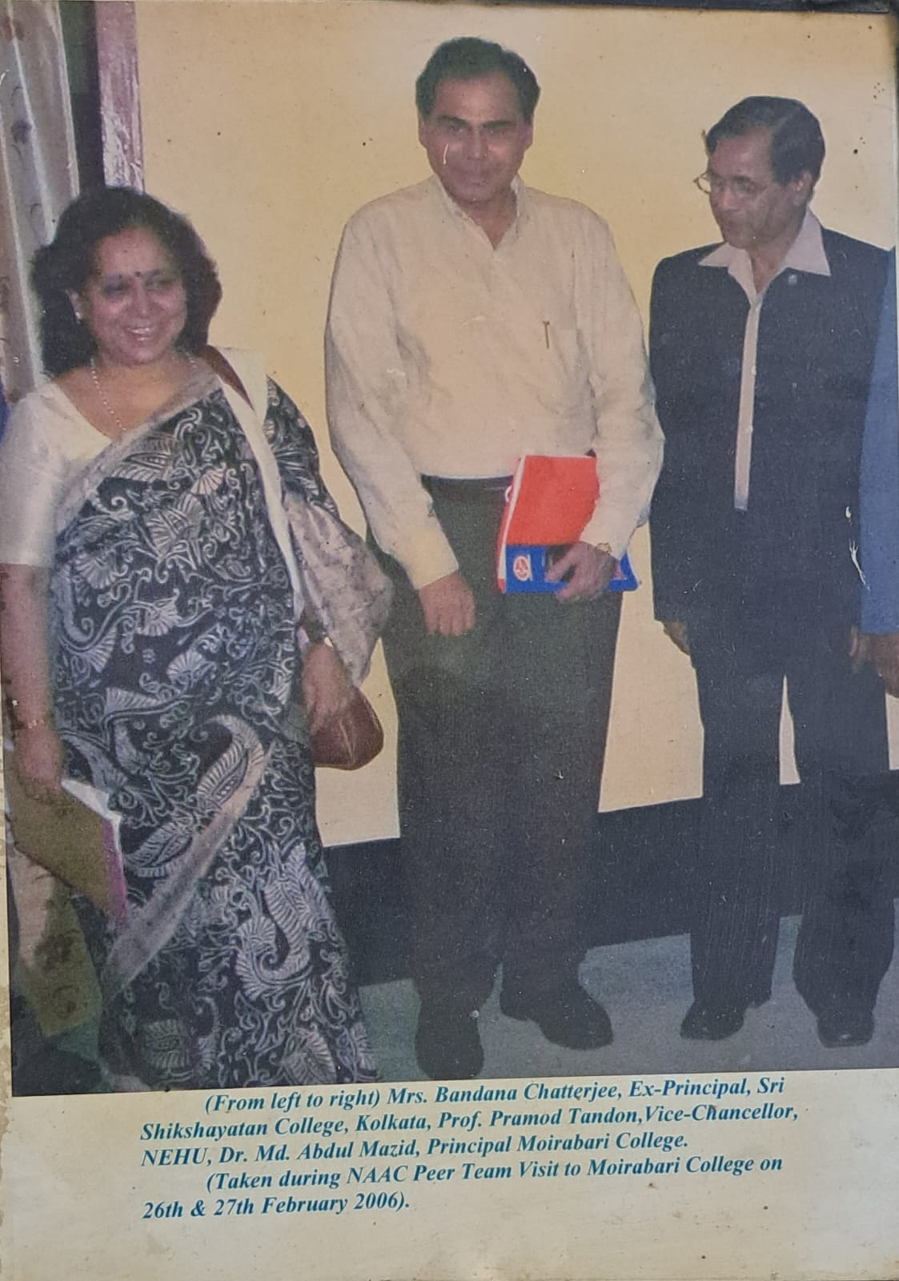
Mrs. Bandana Chatterjee Prof. Pramod Tandon Dr. Abdul Mozid Ex. Principal Vice-Chancellor Principal,
Sri Shikshayatan College NEHU Moirabari College
Kolkata

